**Teammates: Junru Wang, Yifan Meng**

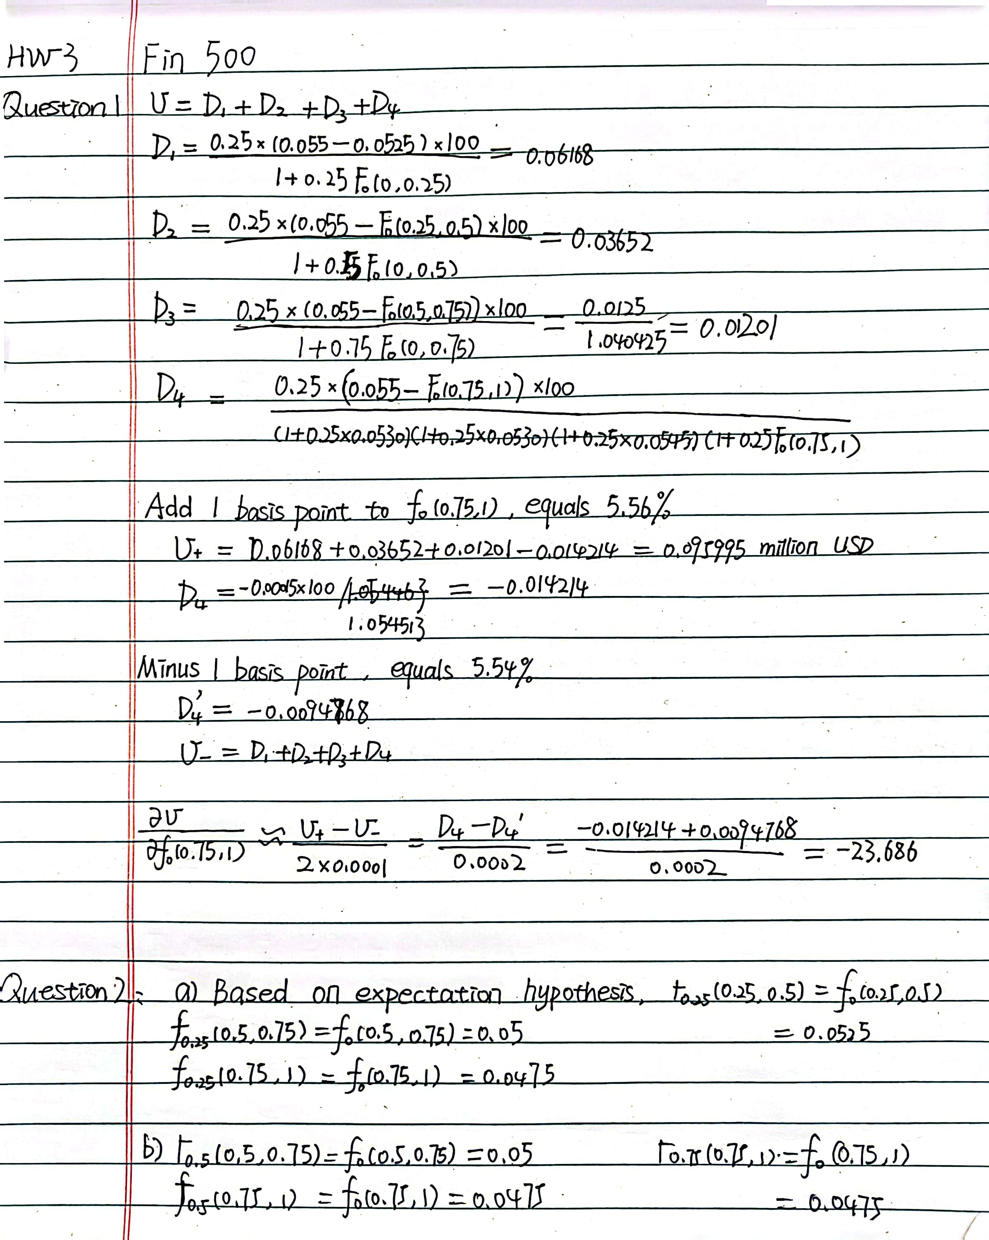



**Question 4**

|  |  |
| --- | --- |
| Yield Curve Parameters |  |
| a0 | **0.062301798** |
| a1 | **0.005734129** |
| a2 | **0.001521117** |
| a3 | **-0.00073538** |
| a4 | **6.57E-05** |
|  |  |
| Sum of squared pricing errors | **0.0046** |

